|  |  |
| --- | --- |
| https://lh6.googleusercontent.com/ENp5iVIZzIHv2b4n4mkS4vHt4UkEBlWYmz738CY-LLW4hqPglKHQ6jUh7UR0d4Ymmrr709Maa1nSxWlKGCsAkajArO1QhFOMQzxwHhEhk0zqlMRi4_H7oj2RIxwzkiz_qKiY_Giy | **Work Integrated Learning Programmes Division**  **M.Tech (Data Science and Engineering)** |

**Data Visualization & Interpretation   
(DSECL ZG555))**

**First Semester, 2020 -21**

**Assignment 1 – PS7 - [AIRLINES DATA ANALYSIS] - [Weightage 12%]**

1. **Problem Statement**

The U.S. commercial airline industry is one of the most diverse, dynamic and perplexing in the world. It is fast-evolving, labour intensive, capital intensive, hyper-competitive and highly susceptible to the ebb and flow of business cycles as well as being among the most regulated of deregulated businesses.

The Airline Data Project (ADP) was established by the MIT Global Airline Industry Program to better understand the opportunities, risks and challenges facing this vital industry. The data has to be analysed to present a view of the industry and its important trends, as well as to identify fundamental drivers of success - and in some cases, the early signs of potential failure.

[Reference](http://web.mit.edu/airlinedata/www/Resources.html)

|  |  |  |  |
| --- | --- | --- | --- |
|  |  |  |  |

**The objectives include**

1. Clearly demonstrate the Visualisation Context.

What questions are you trying to answer/display in your visualizations? Write these as specific questions. You need to come up with 3 questions at least, each of which will be answered using one Viz.

**Chart 1:** How Aircraft Operation Cost varies over the years for various regions, Aircraft Operation Costs for Domestic and International Operations are evidently much higher than the other regions?

**Chart 2:** To forecast the no of passengers for next 10 years for each department based on the historical data from 1995 to 2014 and to see the trend and expected departments to have increased passenger handling

**Chart 3:** How Revenue Per Mile (RPM) changes over the year and which flight type give more profit? What factor affect increasing trend?

1. Chart 1: What type of viz did you create? Why did you select the viz that you did?

**Line Chart: Aircraft Operation Cost over the years.**

**Line charts** are used to track changes over short and long periods. Aircraft costs variation over time for different regions can be compared very well using the Line charts.

1. Chart 2: What type of viz did you create? Why did you select the viz that you did?

**Line chart** is used to show the trend in data, As the data is continuous and represents over a period.

1. Chart 3: What type of viz did you create? Why did you select the viz that you did?

**Grouped Bar Charts – Grouped by fleet type over the year range.** To compare the revenue per mile over the year range, selected vertical bar. The height of the bar describes the change in values over the year, which is easy for interpretation.To show the uniqueness and visual hierarchy on fleet type, grouping has been selected.

1. For each of the Visualisation, identify at least 3 Gestalt principles employed.

**Chart 1: Gestalt Principles:** Similarity, Proximity, Continuity, focal point

**Chart 2: Gestalt Principles:** Continuity, Enclosure, focal point

**Chart 3: Gestalt Principles:** Grouping, Proximity, Common Region

1. For each of the Visualisations, mention the pre-attentive attributes used and how you strategically used them to draw the audience's attention.

**Chart1:**

* **Colour** is used as a medium to denote different regions, thus differentiating the variations in Aircraft operation costs among various region.
* **Form (Line)** is used to denote the variation of the operation costs over the years, thus making it visually evident about the increase or decrease in the operation cost over the period of time.
* **Intensity** is used to bring attention to Aircraft Operation cost for the Domestic and International operations.

**Chart 2:**

* **Colour is used to differentiate different regions**
* **Form (Line)** is used to denote the variation of the operation costs over the years
* **Spatial positioning** is used such that Forecast data is placed next to the historical data hence the audience can comprehend the forecast.

**Chart 3:**

* **Length:** To process visually almost immediately length of the bar is used as a major component in the chart. Implemented bar to compare the data element with in same attribute.
* **Grouping:** We have 3 different type of flight with respect to size, so 3 group are used to minimize the observer conscious effort.
* **Colour Hue:** To bring more attention towards the data on where we have sudden increase, the darker colour is used. Which helps user to give more attention and under that higher variance occurred on particular period.

1. Create your dashboard

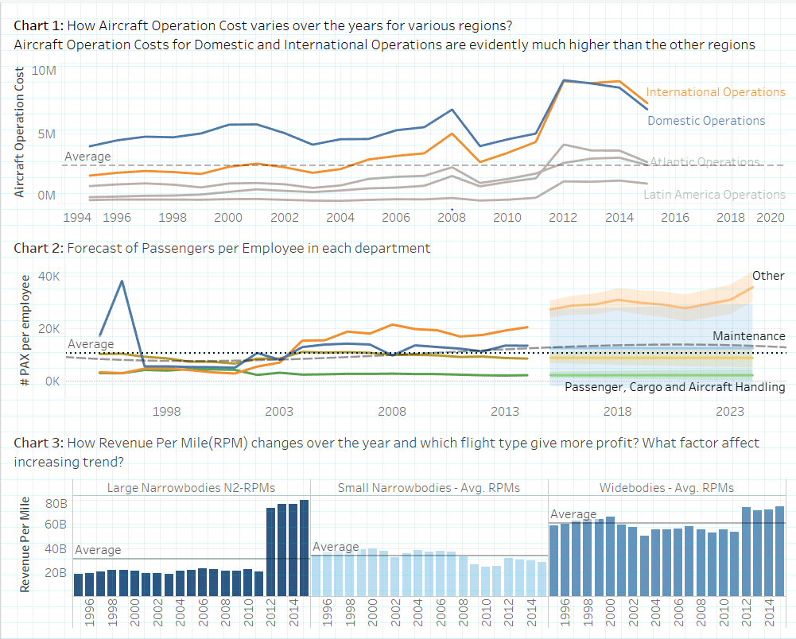

1. **Deliverables**

Zipped file containing

* The word doc with answers to question 1 through 6 above.
* The tableau workbook (.twbx) containing the dashboard.
* The file name should be the respective group name.

1. **Deadline**

* The strict deadline for submission of the assignment is **< January 07, 2021> EoD.**
* Late submissions won’t be evaluated.

1. **How to submit**

* This is a group assignment.
* All members of the group will work on the same problem statement.
* Each group should zip the deliverables and upload in CANVAS in respective locations under ASSIGNMENT Tab.
* Assignment submitted via means other than through CANVAS will not be graded
* **The Assignment is released with the current groups formed as this point in time. There are many groups with Zero members now.**

**If one of you or more than one of you end up being shifted to the other group on your own or by operations, your Assignment number will be the one that is mapped to that Group no and not your old group number from where you have been shifted out.**

**If your submission is the Problem statement of your old group no, then the submission is considered void and awarded Zero marks.**

1. **Evaluation**

|  |  |  |
| --- | --- | --- |
| **Sl. No** | **Criteria** | **Description** |
| 1 | Data Preparation + Effective usage of context  (15%) | * Clearly identify the context using the concepts learnt in the class |
| 2 | Choice of appropriate visuals  (25%) | * Identify the appropriate visuals while communicating the message. Use the design principles and strategies while drafting the presentation |
| 3 | No clutter in the visuals  (25%) | * The visuals presented should not have any unwanted elements that reduces the understanding of data |
| 4 | Audience attention  (10%) | * The visuals presented should have the right kind of visual clues- Gestalt Principles and Pre-attentive attributes- that helps the audience to focus the attention wherever required. |
| 5 | Effective storytelling  (25%) | * Use Principles of Effective Dashboard Design to come up with an interesting Dashboard |

**ALL GROUP MEMBERS WILL BE CREDITED THE SAME MARKS.ITS INDIVIDUAL’S RESPONSIBILITY TO ENSURE HIS/HER PARTICIPATION AS WELL AS TEAM’S RESPONSIBILITY TO ENSURE EVERYONE’S PARTICIPATION.**